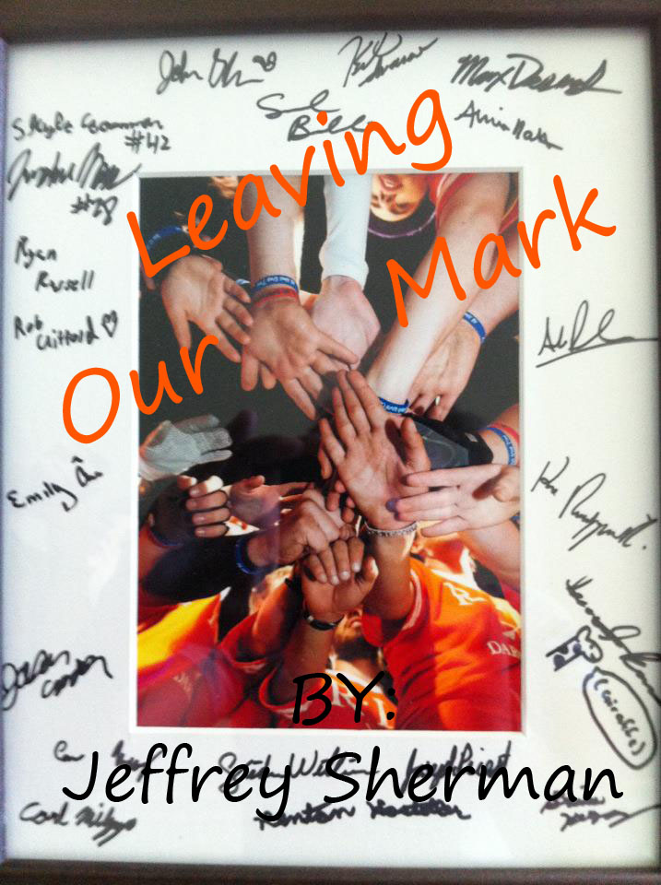

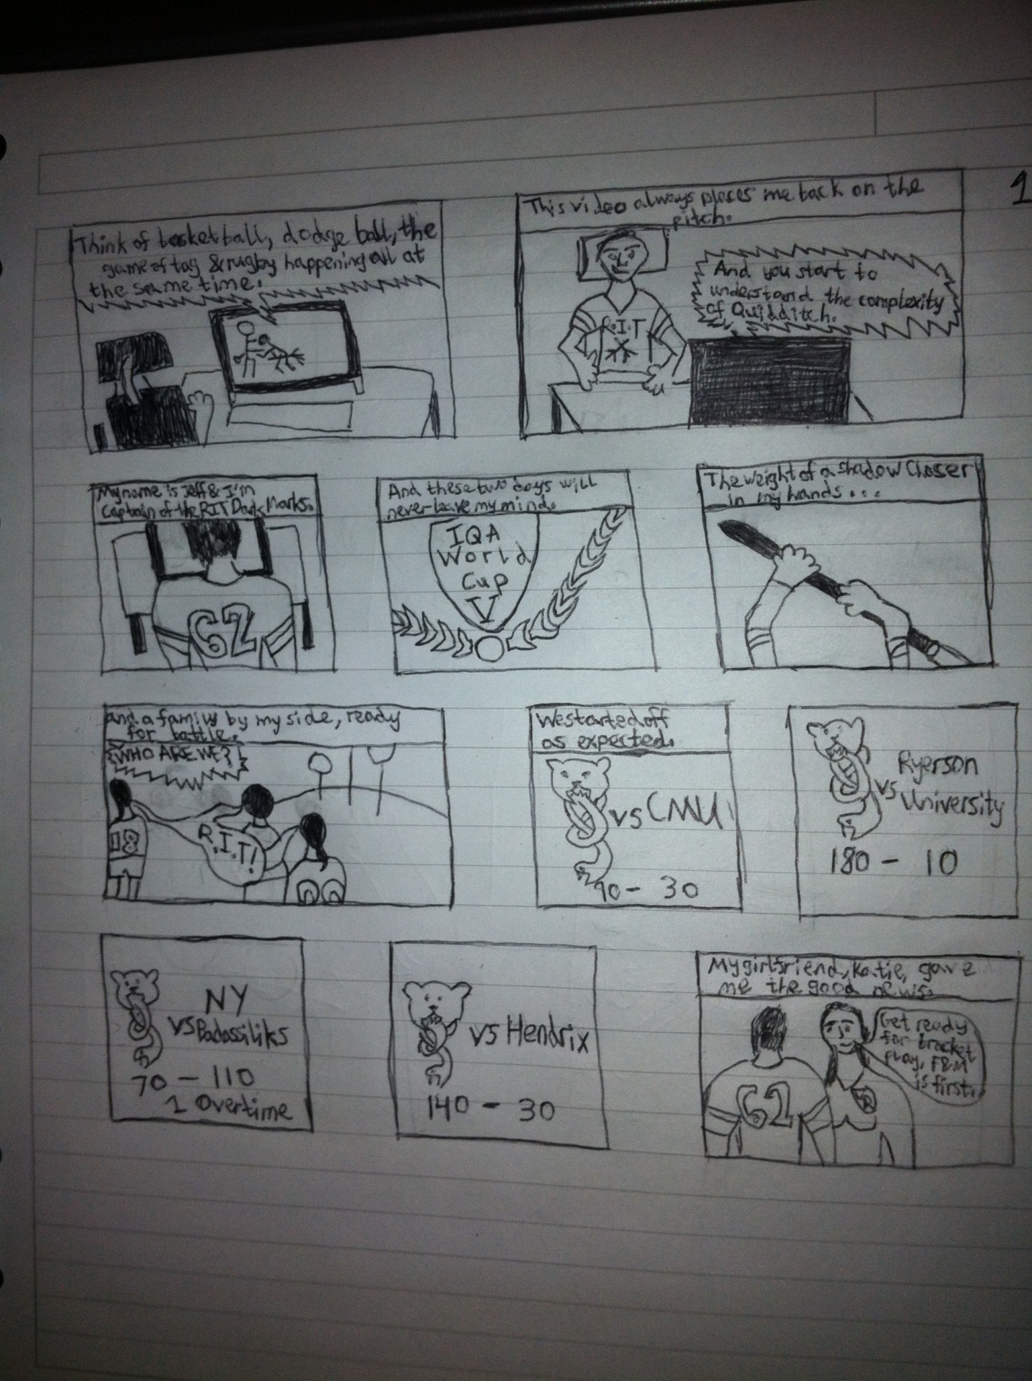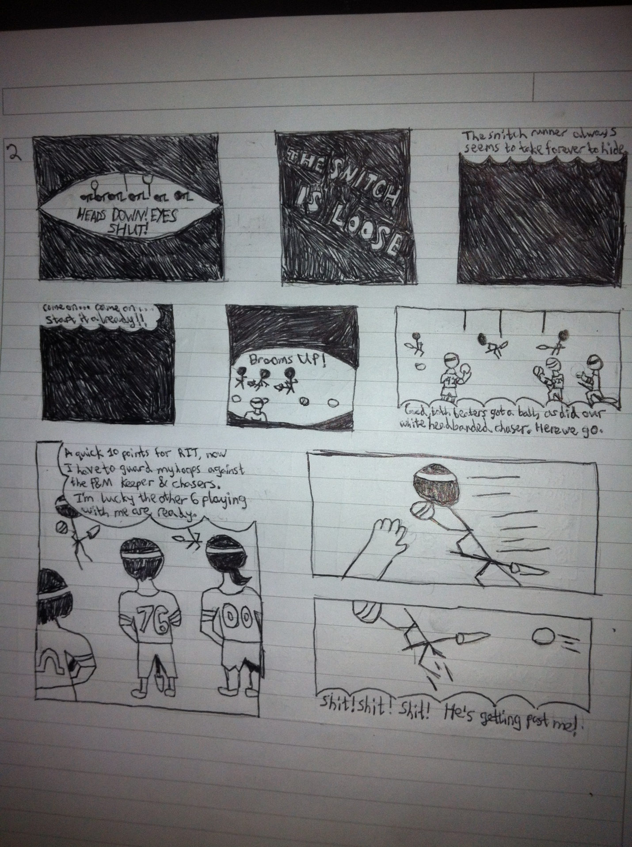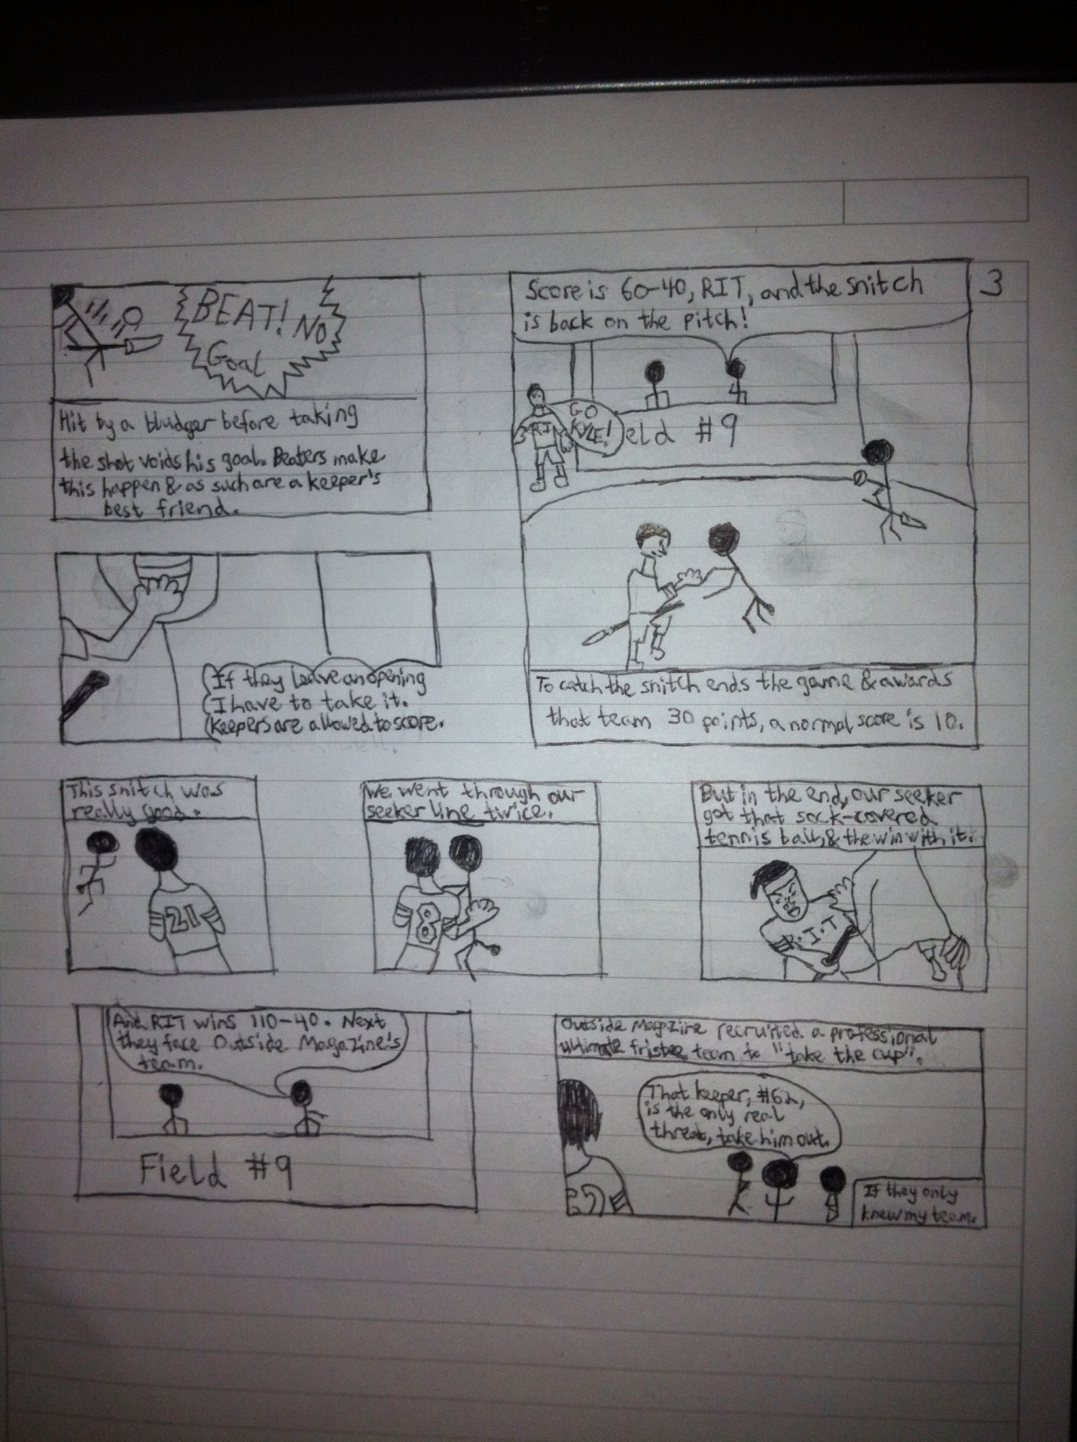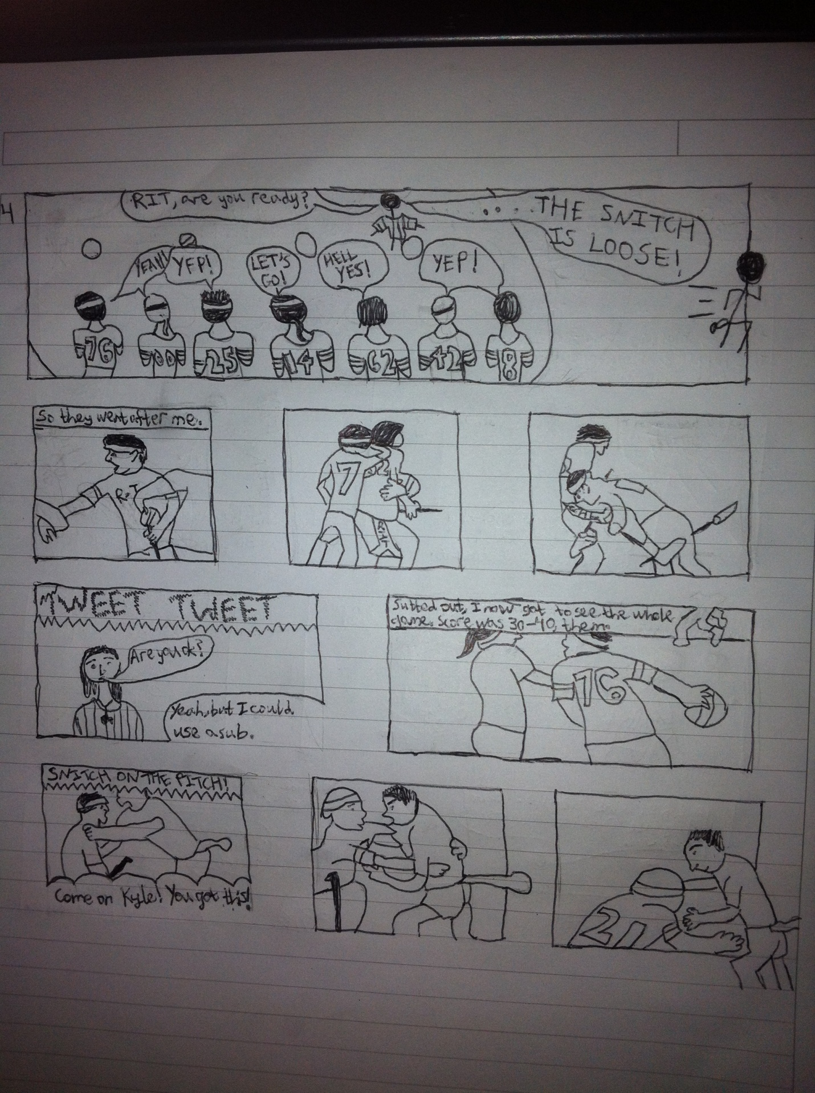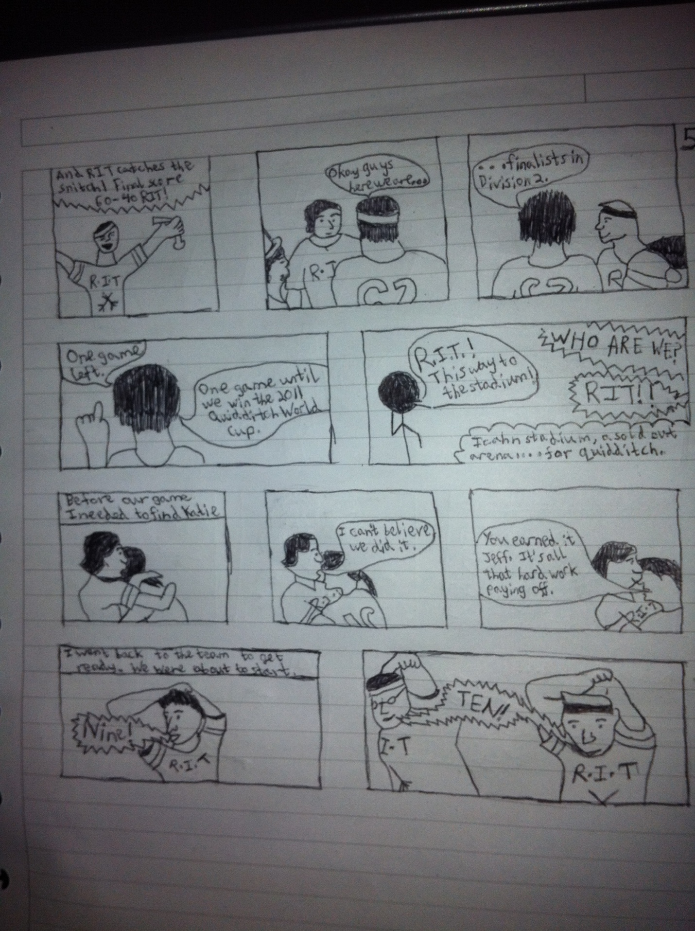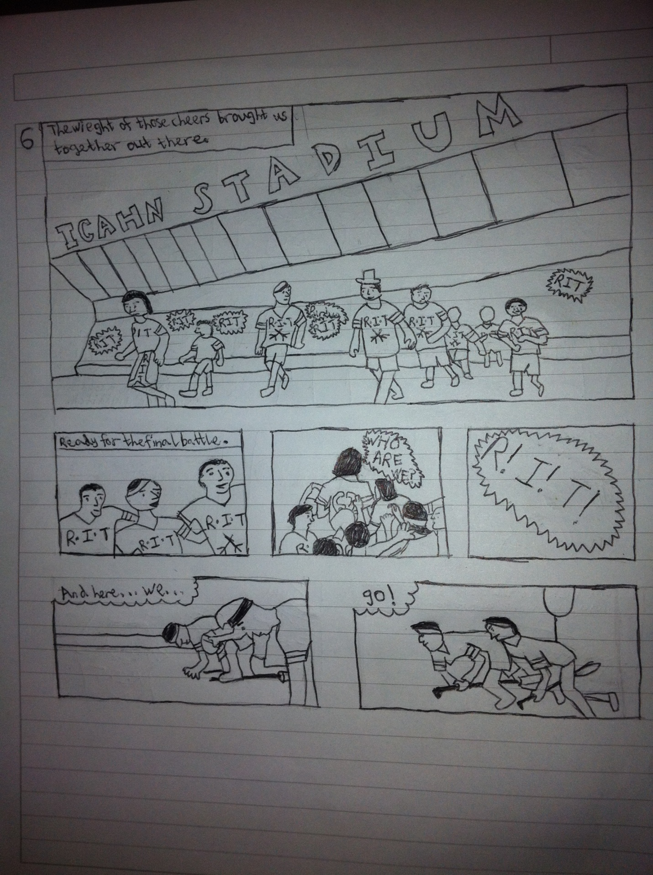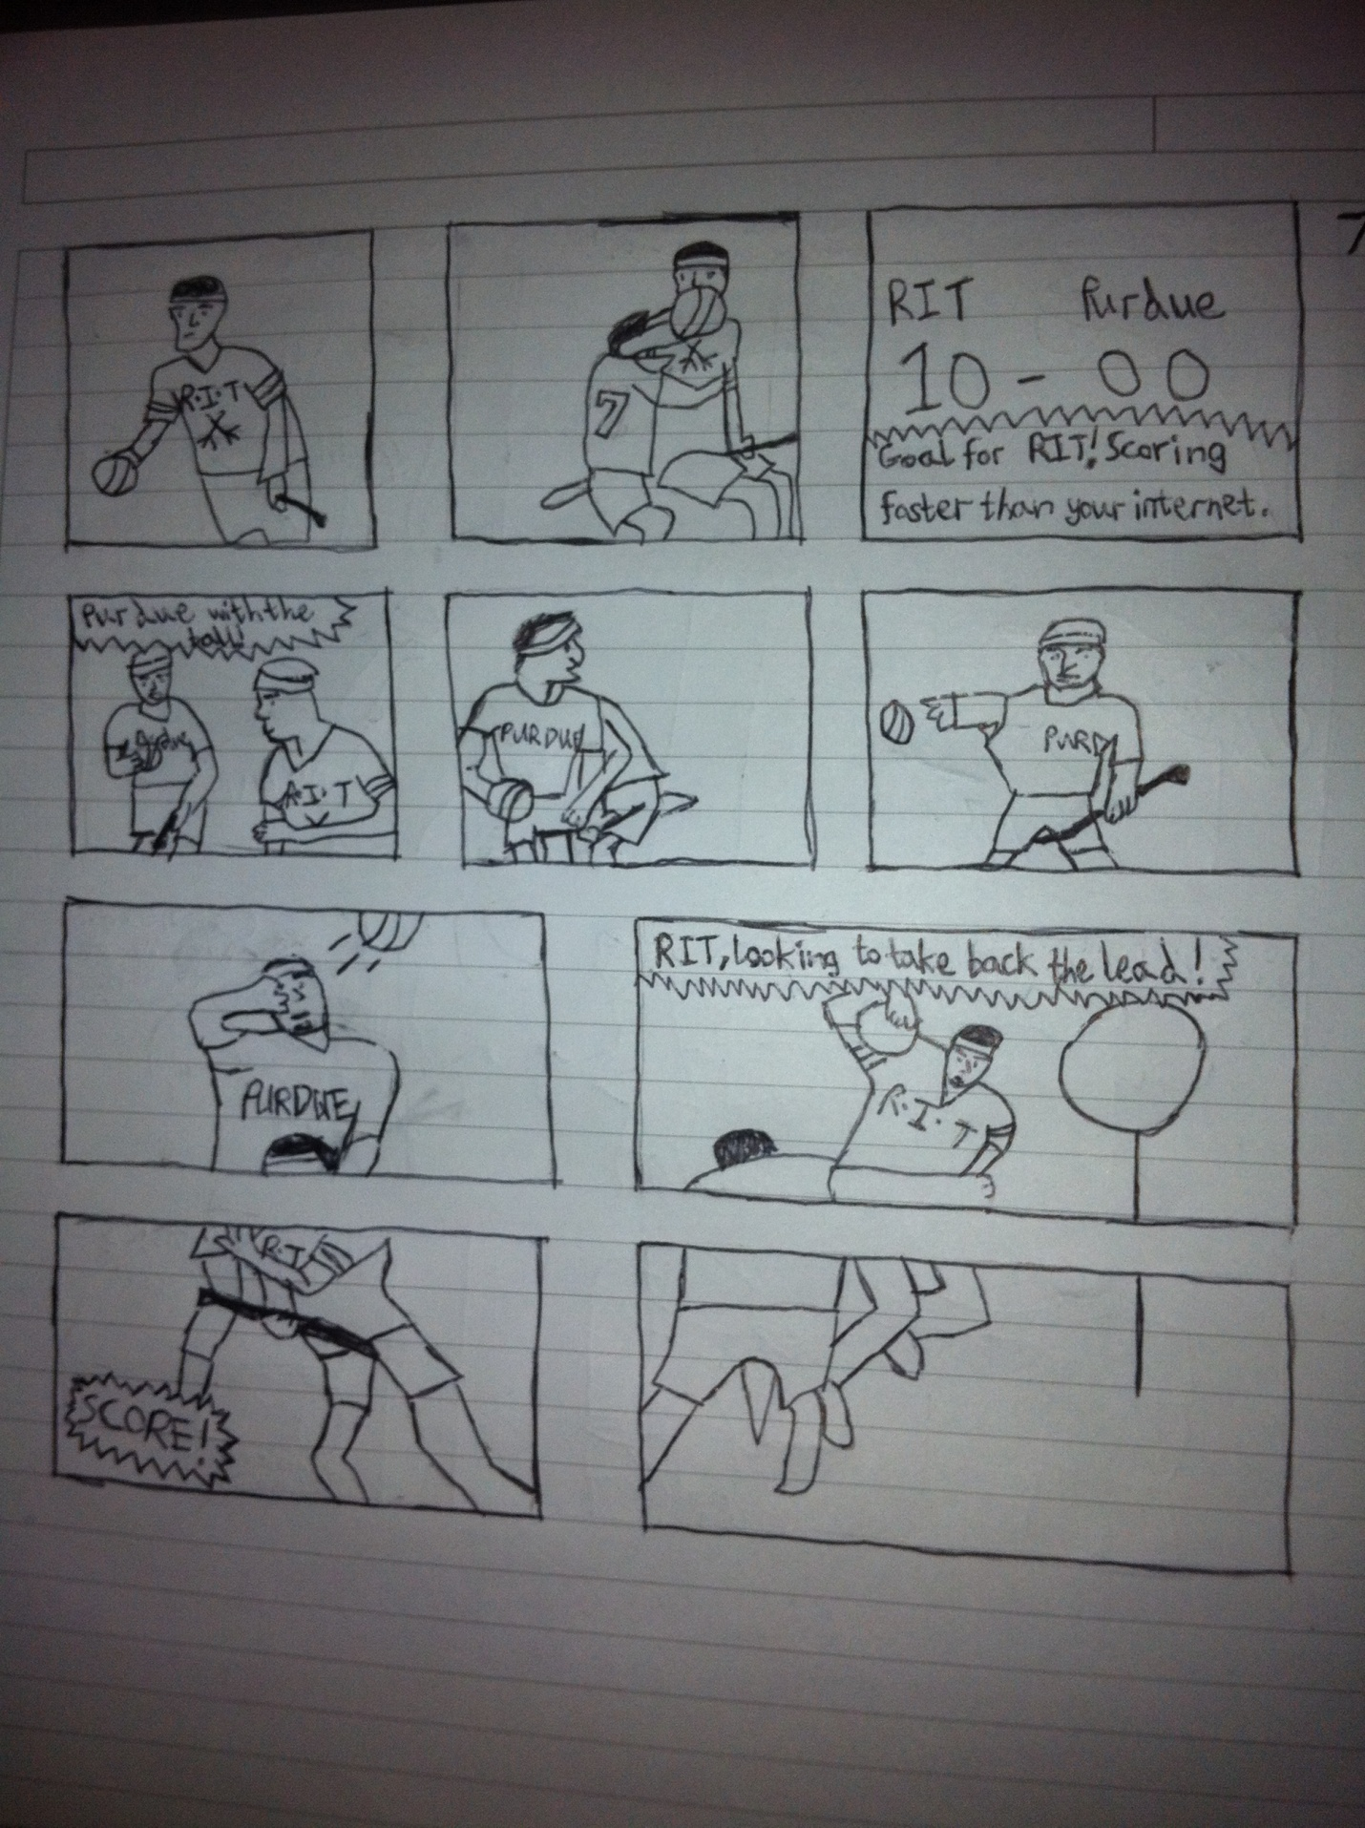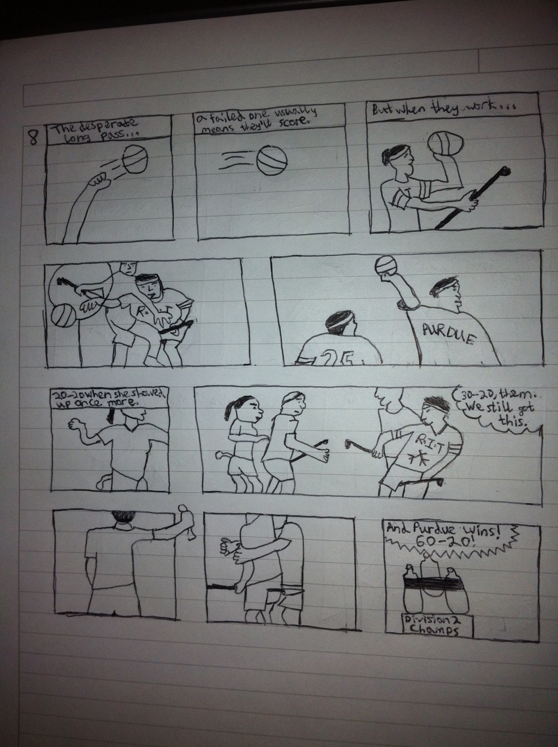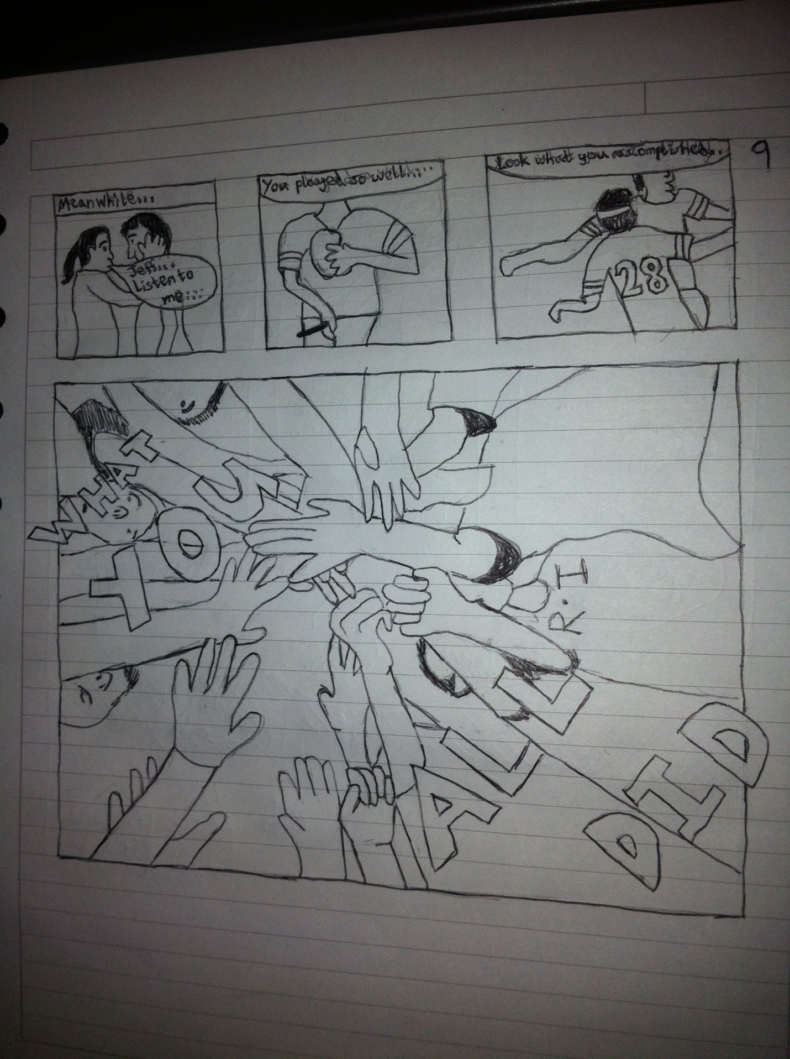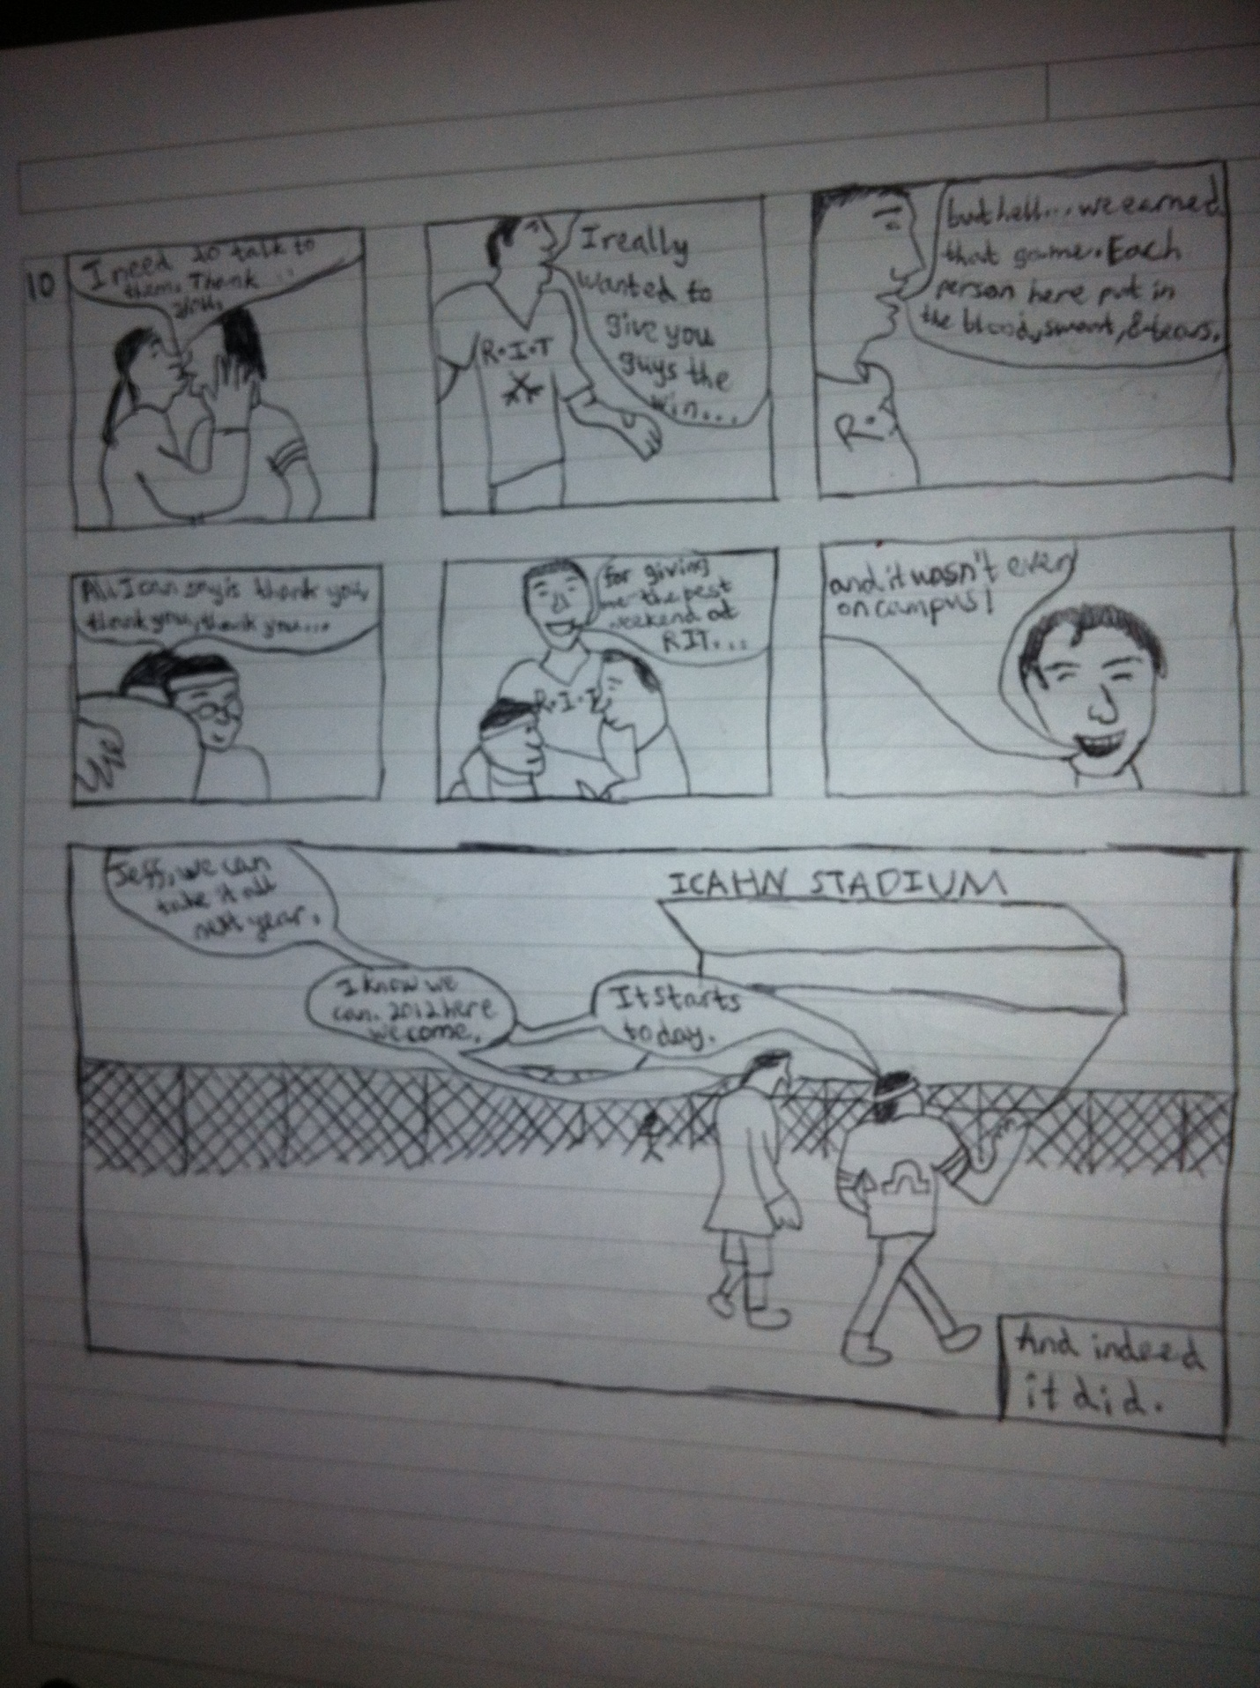

Jeffrey Sherman

Professor Perry

Graphic Narratives

5/22/12

Leaving Our Mark Artist Statement

This comic was a fun and cathartic one to write. All the events that I depicted within those pages happened. The hard part was finding what to focus on and how to do it in a way that would make sense to those beyond my fellow quidditch players. It was the first time I had written a graphic novel, but not my first comic, so some of the choices I needed to make weren’t new to me. How to use panel frames, how to lay them out, and what colors if any I should use in telling my tale.

I was influenced by Charles Burns’ use of black and white to create moods and to show the world. Combine that with Chris Ware’s evolving style in the ACME Novelty Library and I think that describes this comic the best artistically. Now, I’ll be the first to admit that I am nowhere near either man’s artistic abilities. But that sense of conveying emotion and setting a mood using only black and white was something I was trying to do. It’s easier to see Ware’s influence. Early on in the comic, the only characters that are fully drawn are members of my own team. Everyone else is just a stick figure, interchangeable with one another. Even the first four games, the entire first day, are shrunk down into four panels. Then as the games became more intense – and thus memorable – others at the cup become more flushed out. This culminates in the final game with every panel having people on both teams looking more realistic than iconic.

I knew that the very idea of Muggle Quidditch would be something I had to teach the reader as they read the graphic novel. As such, I didn’t want to distract them more with overly complex panel layouts. I also didn’t want to transcribe a page of the basics of quidditch because that would make things boring. With quidditch embodying the idea of learn by doing, it’s better to watch things in action rather than read text about it. I did include some rules within the pages to maintain a level of accessibility to those who had never heard of the game before. This balancing act was what sparked my inspiration for the top of page 2. At the start of each game, all players shut their eyes to allow the snitch runner to hide. I wanted to give a sense of what it felt like to be playing a game, so I put it from my own perspective.

As much as I am the reason for why this story is being told I wanted the reader to get a sense of everyone on team being an equal member and of equal importance. That’s why I chose the cover picture to be a picture of everyone’s hands. Not a full face shows because just like in *Miracle* all that matters is the name of the team on the front of the jersey. I also wanted to use images that stood out in the team’s mind the most. In talking with everyone, the two were walking into Icahn Stadium and the hands in picture used for the cover. It may be an obvious way of conveying the images importance, but having the larger panel size also is how I chose to show how time seemed to slow down during those moments. I ended with the large panel because it is how the cup ended for me, and has a sense of hope and walking into the future. Walking off the panel in the way the reader’s mind moves across the scene, combined with the subject of conversation shifting to the future, contributes to the sense of looking ahead.